CS/EE 120B

Custom Project: Alarm Clock System

June 10, 2018

# Introduction

Hi my name is Winson Bi, and this is my alarm clock of the future, prototype. It differs from alarm clocks of today as it shoots out a harmless projectile when the alarm goes emits a noise and continues to emit the noise until the projectile is returned to the device. This device is perfect for people who have a hard time getting out of bed and are for the type of people who turn off their alarm clocks in their sleep.

My complexities are the motor driver that controls the two motors, I am using eeprom to store the alarm time, using a nokia 5110 lcd panel and using an infrared break beam sensor to detect if the harmless projectile is in its launch position.

When setting the alarm and time entering an invalid time will cause the device to reprompt you before asking you for the AM or PM. The device starts with the alarm automatically off and can not be turned off by the alarm on/off button when the alarm goes off. The only way for the alarm to go off is to to pick up the device and return it. While this prototype won’t shoot far due to the weak motors, it still does well to demonstrate the concept. 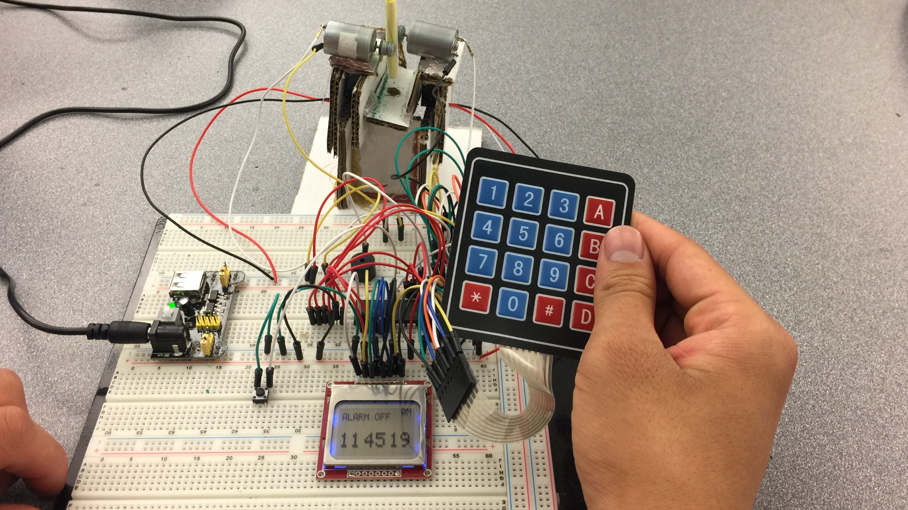

User guide

To turn on the device press the on button on the power supply. The alarm always starts in the off position on start up for safety reasons. Then to set the time by pressing A as it will be set to the default time every time turned off and then turned on again. Then to set the alarm time you press B, the alarm time will be remembered in the ATMegas EEPROM so it will be saved even if you turn the device off( unlike the regular time). In both, if you put an incorrect 12 hour format time it will reprompt you for the time until you put a valid time then it will prompt you for AM/PM. After you have set the desired alarm time, you can turn the alarm on and off with the button, when the alarm is set to on you will see the screen say “ALARM ON” with the alarm time displayed next to it, else if the alarm is set to off it will simply display “ALARM OFF”. As a safety feature the alarm can not be turned on if the projectile is not inside the launch hole, this is to prevent the alarm from going off if you attempt to reinsert the device. Once the alarm time is reached, the device will shoot the projectile and begin the alarm. The alarm will continue to emit sound until the projectile is returned to the alarm clock, causing the person to get out of bed to turn off the alarm.

# Hardware

## Parts List

The hardware that was used in this design is listed below. The equipment that was not taught in this course has been bolded.

* ATMega1284 microcontroller
* Speaker
* Number Keypad
* Button
* **L293D Motor Driver**
* **Nokia 5110 LCD Panel**
* **ATMega EEProm**
* **IR Adafruit Break Beam Sensor**
* **Two DC Motors**

# Components (Pin-out)

* **Inputs**
  + Sensors around launcher to sense when the harmless projectile is stationed
  + Buttons to set the time
* **Outputs**
  + DC Motors to launch the harmless projectile
  + Speaker for noise
  + An LCD Panel for displaying time

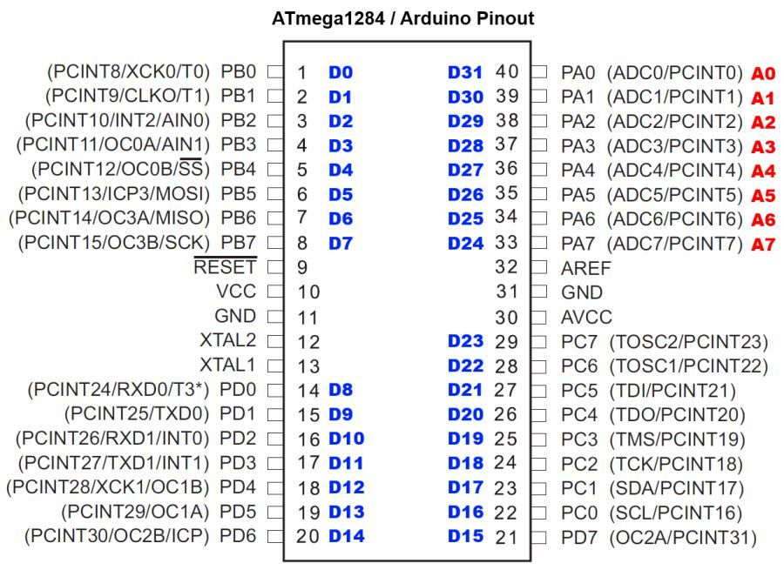

# Software

* + AVR Studio 6

This is the section where you will input the images of the state machines that you designed.

**Libraries included from others:**

https://github.com/LittleBuster/avr-nokia5110

/* Nokia 5110 LCD AVR Library  
 *  
 * Copyright (C) 2015 Sergey Denisov.  
 * Written by Sergey Denisov aka LittleBuster (DenisovS21@gmail.com)  
 *  
 * Original library written by SkewPL, http://skew.tk  
 */

-Used this library to help display on the Nokia 5110 LCD Panel

**State Machines**

**Shared Variables:**

**unsigned char AlarmSetDisplay = 0;  
unsigned char TimeSetDisplay = 0;  
unsigned char AlarmOn = 0;  
unsigned char AlarmOff = 0;  
unsigned short Time = 42200;  
unsigned short AlarmTime = 0;  
unsigned char AlarmAMPM = 0;  
unsigned char TimeAMPM = 0;  
unsigned char timeChange = 0;  
unsigned char SMTimerAMPM = 0;  
unsigned short newTime = 3600;  
unsigned char MotorOn = 0;  
unsigned char PlaySpeaker = 0;**

**Helper Functions:**

**void DisplayTime (unsigned short val);  
//takes a time in seconds and generates the correct hours minutes and seconds then renders that**

**void AlarmTimeDisplay(unsigned short val , unsigned char val2);  
//Same as TimeDisplay but displays the miniature alarm time when alarm is set to on**

**void AMPMHelperFunction(unsigned char val);**

**//sets AMPM for Display**

**unsigned char GetKeypadKey();  
  
SMDisplay**

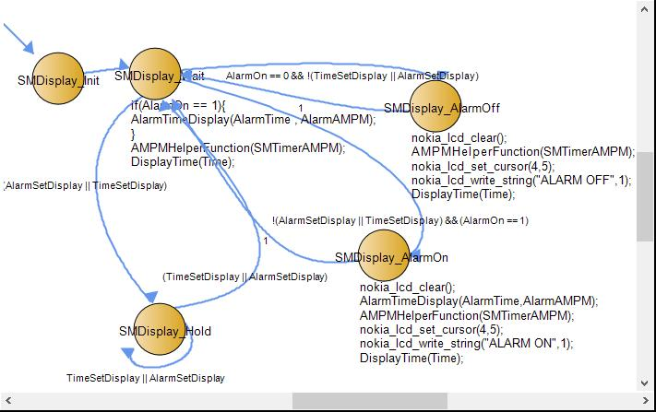

# **SMTimer**

# static unsigned char i = 0;

# **SMTimeset** //Picture was stitched together from smaller pictures from RIBS

static unsigned char i = 0;

static unsigned char hour1,hour2,minute1,minute2,second1,second2 = 0;

static unsigned short temp;

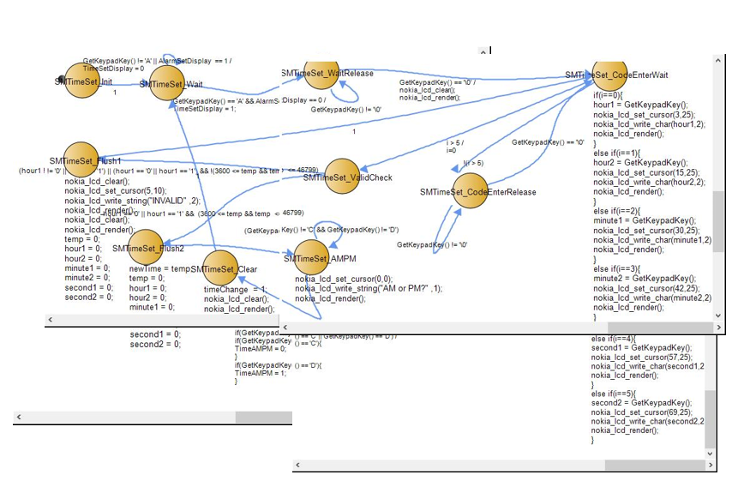

# **SMAlarmSet**

static unsigned char i = 0;

static unsigned char hour1,hour2,minute1,minute2,second1,second2 = 0;

static unsigned short temp;

# 

**SMMainState**

static unsigned char match = 0

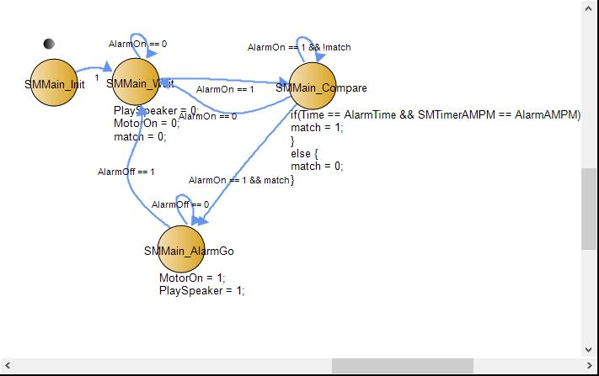

# **SMMotor**

unsigned char sensor = PIND & 0x02;

static unsigned char count = 0;

# 

# **SMPlaySpeaker**

//This FSM basically plays all the notes with rests inbetween each unless in a continuous loop while

//PlaySpeaker == 1 and will go back to the wait state and play nothing when PlaySpeaker == 0

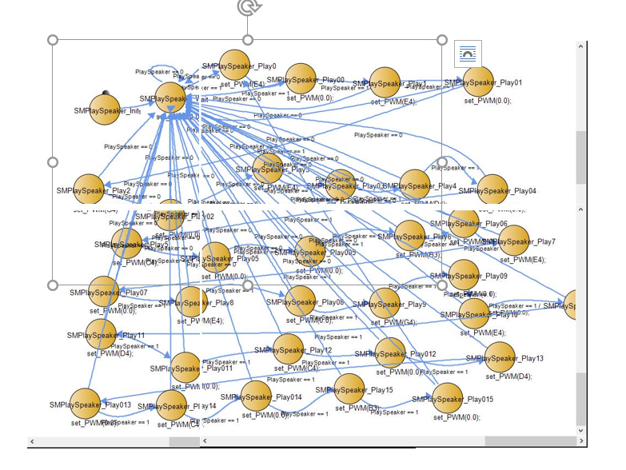

# Complexities/Build-upons

Completed Complexities:

1. Using an Nokia 5110 LCD Panel to display the time and alarm on/off display.
2. Keeping Track of the Time and Saving the Alarm Data in the EEPROM so it will remember alarm data even after being turned off.
3. Using a sensor to sense if the projectile is in the launch hole.
4. Using a motor driver to drive the motors used to propel the projectile.

# 

# Youtube Link

https://www.youtube.com/watch?v=4-58_lbmufw

# Known Bugs and Shortcomings

* The System period is 250 ms and thus requires you the hold and press all button for possibly 250 ms to be registers causing some button presses to not be registered, also the Number Keypad used in our class has a tendency to get stuck and thus sometimes have a hard time registering presses.
* Also a very large bug is that you can totally circumvent the device and just cover the sensor if you knew how the device worked to also turn off the alarm. This can be fixed by using a different type of sensor, one with two parts, one that is stationary in the launch hole and one inside the projectile to know where the projectile is in respect to the launch hole.
* You can also just circumvent the whole alarm system by unplugging it, this can be solved by using a battery and perhaps a consistent renewable energy source or some radioactive material to power the device over a long duration.

# Future work

In this section pretend for a moment that you were going to continue working on the project. What would be the next feature you would add?

I would use stronger motors,and add a way to set upload your own alarm songs. Also I would include a different type of projectile launcher that is more elegant than this one, perhap shooting a disc instead and having the alarm clock shoot out a foam disc out of a slot and the alarm would turn off after your return the foam disc into the slot. Also I would use a nicer LCD Panel so the timer is easier to see. Maybe also run the clock off battery and a renewable energy source so it can keep the time when the device is off and also allow the alarm clock to be more portable and it will not be able to be unplugged to turn it off.